PROJECT NAME : AGRO BOT UNIVERSAL AI BASED AGRICULTURAL ASSISTANT
WEEK -2 ASSIGNMENT
(PASUNURI POOJA- poojareddypasunuri@gmail.com MALLA REDDY ENGINEERING COLLEGE FOR WOMEN)
GITHUB LINK: https://github.com/Pasunuri-Pooja/agri-chat-bot.git

STEP 1: Registration Page & Login Page
Users start by registering with a username and password to create a secure account.
The login page allows returning users to access personalized AI-driven agricultural advice.
Both interfaces feature a simple, user-friendly design for easy navigation.
New users can swiftly transition from registration to login for seamless access.
Agro Bot Universal ensures secure management and tailored assistance for every user.

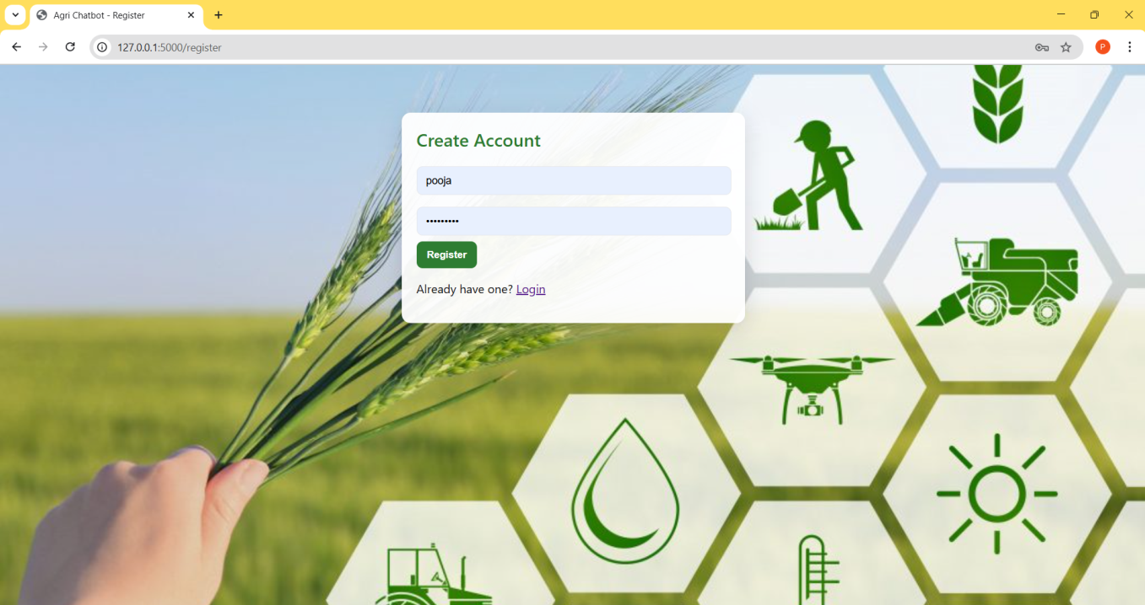
Registration page
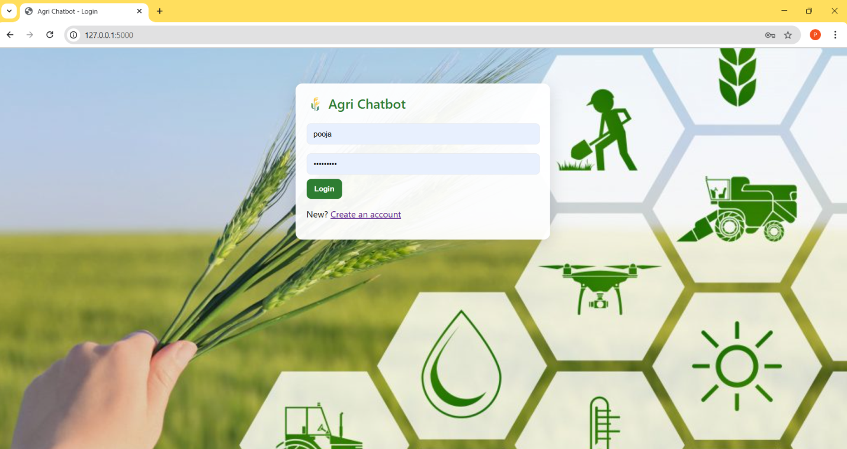
Login page

STEP 2: Chatbot Page
The chatbot page of Agro Bot Universal serves as the main interaction hub where users can communicate directly with the AI assistant for agricultural support.

Chatbot Page Features
- After login, the user is greeted by name and given an interface to chat with the AI assistant about farming topics.
- The chatbot responds to user queries related to agriculture, such as soil, fertilizer, pests, and harvesting, providing expert guidance and solutions.
- If the AI does not understand the question, it politely asks the user to clarify or to ask about supported topics.
- The interface includes a language selection dropdown, allowing users to interact with the chatbot in English, Tamil, Hindi, Telugu, or Malayalam, supporting accessibility for diverse users.
- The design is visually engaging, with agricultural icons and a background image that sets an inviting, farmer-friendly tone.
This intuitive chatbot interface enables users to quickly get answers to farming questions, making agricultural expertise easily accessible to everyone on the platform.
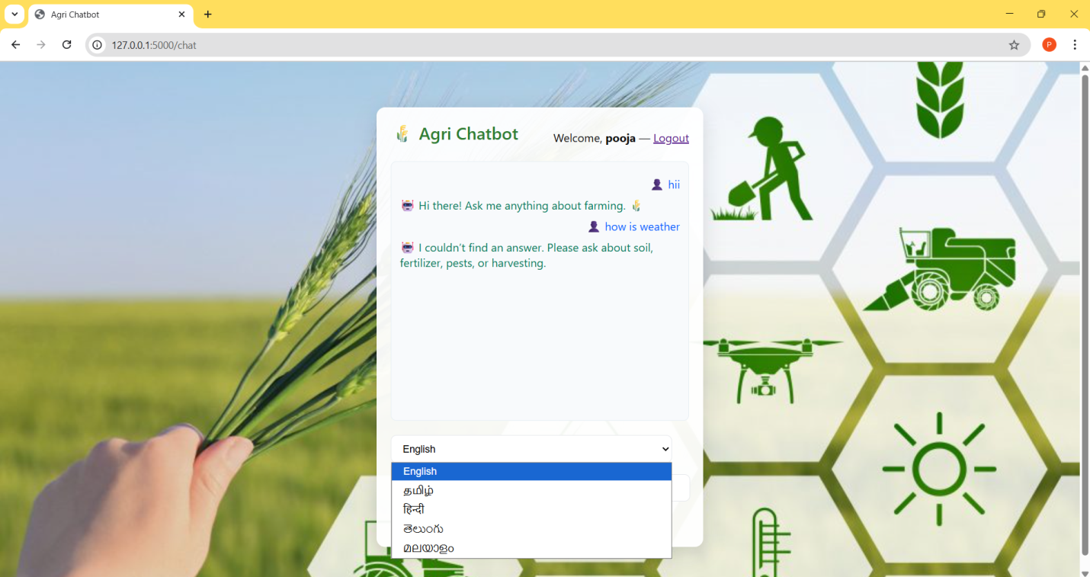
Chatbot page

